HOW TO DEFINE AN ACL RESOURCE

1. Define an ACL resource:  
   Add an element into class ACLResourceEnum. Ex: define an ACL resource for UomCategory.

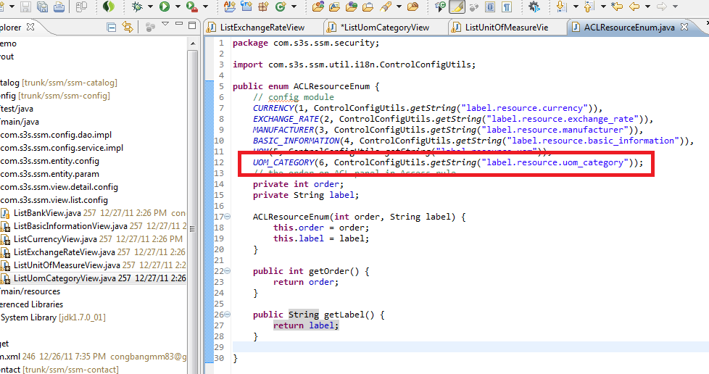

Define a label i18n for this resource:

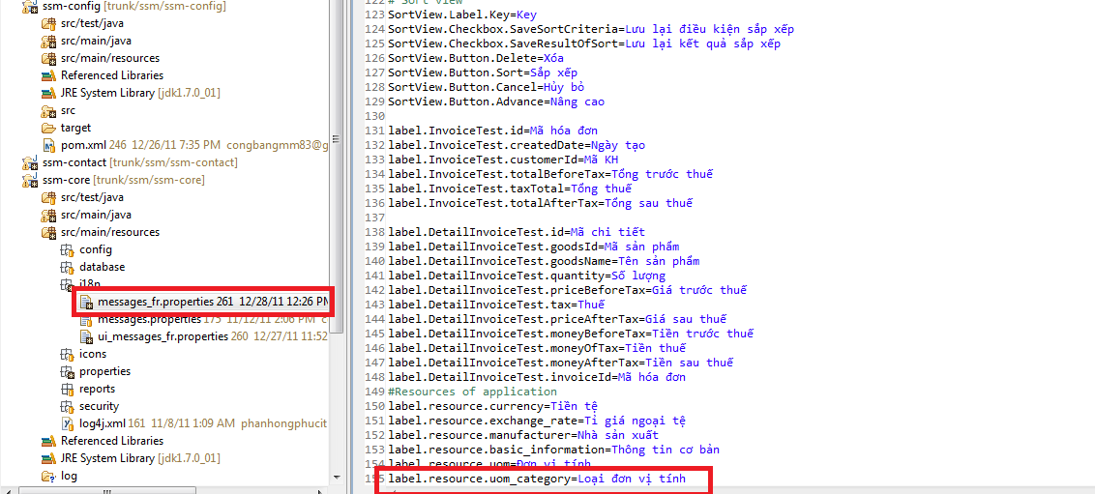

1. Apply new ACL resource into application:

Overriden the method “registerACLResource” in class AbstractDetailView.

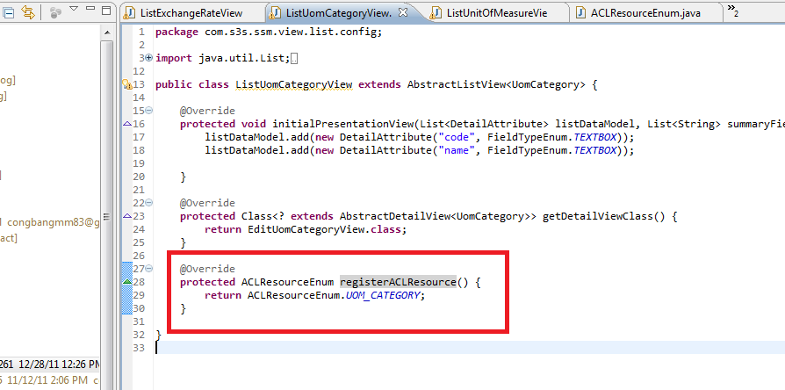

1. Result on ACLPanel when setting access rule for a role:

